IMPLEMENT HIERARICAL CLUSTERING

AIM
To perform Hierarchical Clustering on a dataset containing Hours_Studied and Marks using the Agglomerative Clustering algorithm, visualize the clusters using a dendrogram and scatter plot, and group the data points into three clusters.

ALGORITHM
- Import the required Python libraries: Pandas, Matplotlib, SciPy, and Scikit-learn.
- Load the dataset data.csv using Pandas.
- Select the features Hours_Studied and Marks for clustering.
- Calculate the linkage matrix using the Ward linkage method.
- Plot the dendrogram to visualize the hierarchical relationships between data points.
- Apply Agglomerative Hierarchical Clustering with the number of clusters set to 3.
- Predict the cluster labels for each data point using fit_predict().
- Add the cluster labels to the original dataset as a new column named Cluster.
- Print the dataset with the assigned cluster labels.
- Plot a scatter plot using Hours_Studied and Marks, with different colors representing the clusters.

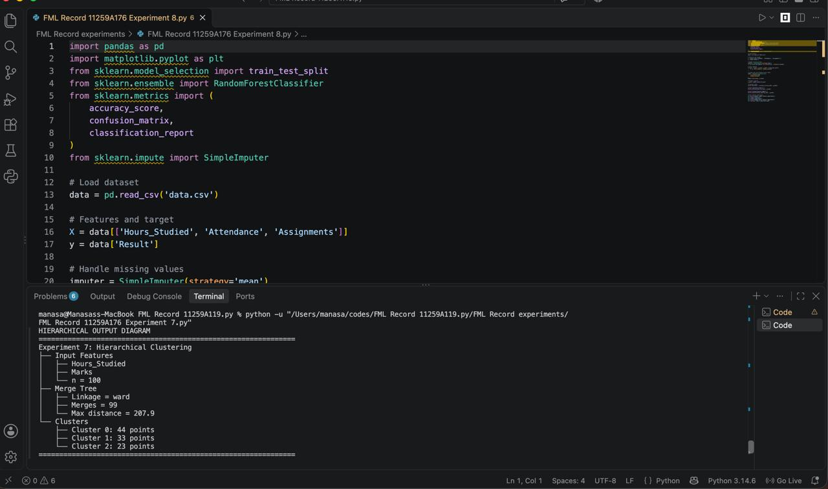
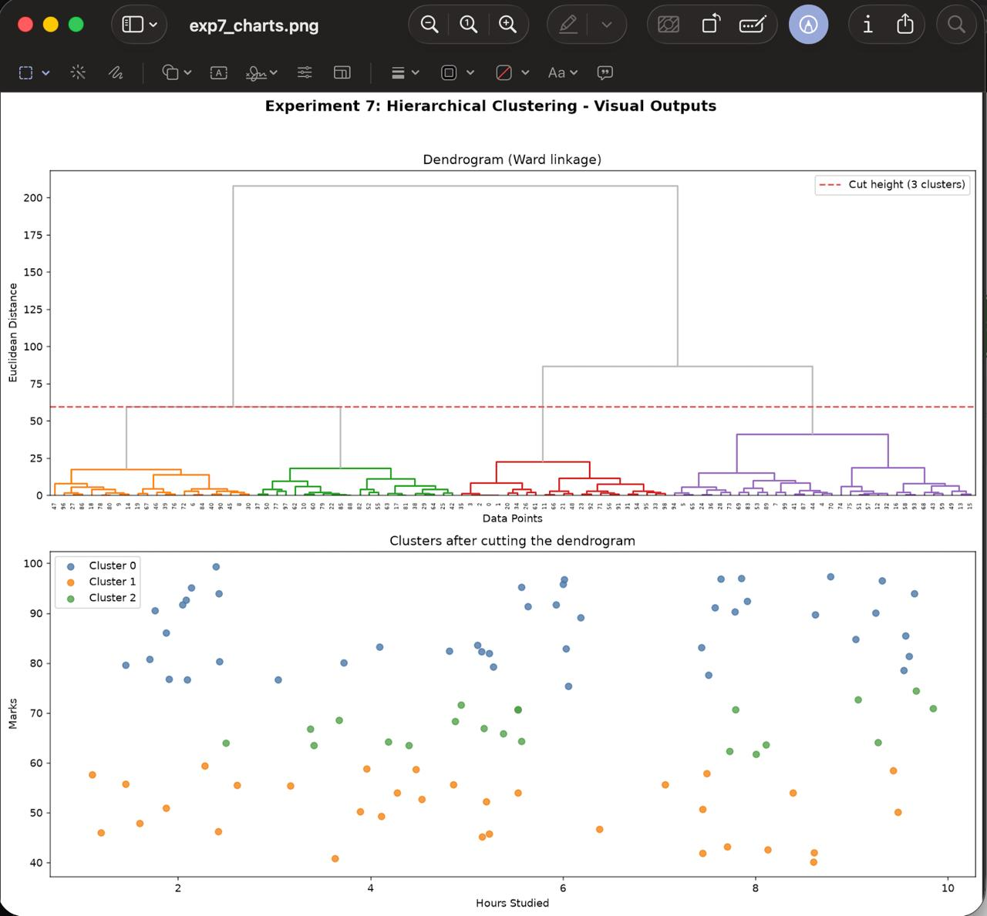

RESULT
Thus, Hierarchical Clustering was implemented successfully using the Agglomerative Clustering algorithm. The dendrogram was plotted to show the hierarchical relationships among the data points, and the scatter plot was used to visualize the three clusters based on hours studied and marks obtained.
The dataset was updated with a Cluster column containing the assigned cluster labels.

